Below are the steps to upload the results in Zephyr Scale.
- Generate the access token
- List of APIs required to develop this project.
Get Folder
  - Get folder
  - Get folders
  - Get Project Details
  - Get test cycle data
  - Upload xml results
  - Update test cycle.
- Creating the folder, sub folder structure as per the requirement.
- Generate XML Report as per the requirement.
- Upload the XML results as per the requirement.

Let's go through this in detail,

Generate the access token:

On the home page of Zephyr Scale , please select Zepyhr Scale API Access token , it will open API access tokens page , in the page please click on create access token button.
This token will be useful across the project.

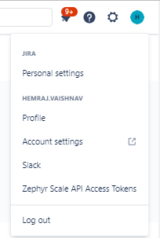

List of APIs:

Get Project: This API will be useful to get the required project details like Jira project ID,enabled,key.

- Endpoint URL: https://api.zephyrscale.smartbear.com/v2/projects/{projectIdOrKey}
HTTP method: Get
- Input: ProjectID or Key
- Output: Respective project details in JSON format.

{
"id": 0,
"jiraProjectId": 0,
"key": "string",
"enabled": true
}

For more Information please refer below link,
https://support.smartbear.com/zephyr-scale-cloud/api-docs/#operation/getProject

2. Get Folders: This API will be useful to get the folder details which exists in Zephyr Scale.

- Endpoint URL: https://api.zephyrscale.smartbear.com/v2/folders
- HTTP method: Get
- Output: Respective project details in JSON format.

For more Information please refer below link,
https://support.smartbear.com/zephyr-scale-cloud/api-docs/#operation/listFolders

Example:

The respective Automation Run folder details are as below in PAN project.

The folder ID is : 1694948 and folder type is TEST_CYCLE.

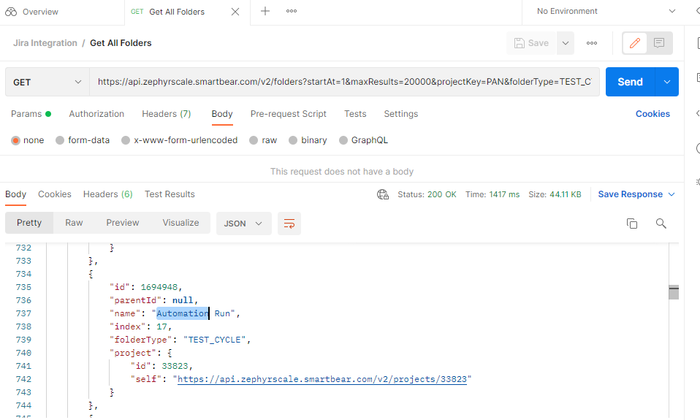

Project Screen:
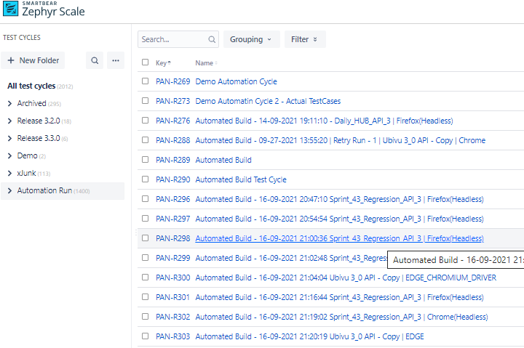

- Get Folder: This API will be useful to get the folder details which exists in Zephyr Scale.

Endpoint URL: https://api.zephyrscale.smartbear.com/v2/folders/{folderId}
HTTP method: Get
Output: Respective project details in JSON format.

For more Information please refer below link,
https://support.smartbear.com/zephyr-scale-cloud/api-docs/#operation/getFolder

Example:
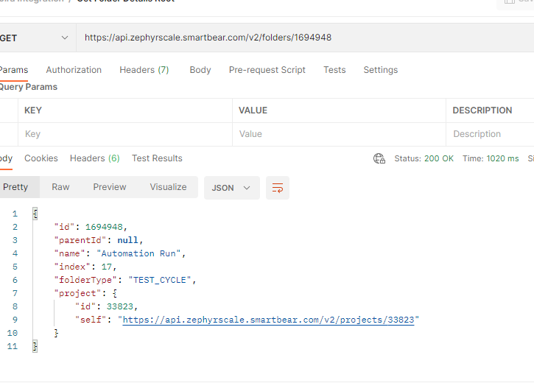

4. Get test cycles: This API will be useful to get the list of all test cycle details which exists in Zephyr Scale.

Endpoint URL: https://api.zephyrscale.smartbear.com/v2/testcycles
HTTP method: Get
Output: Respective project details in JSON format.

For more Information please refer below link,
https://support.smartbear.com/zephyr-scale-cloud/api-docs/#operation/listTestCycles
Example:
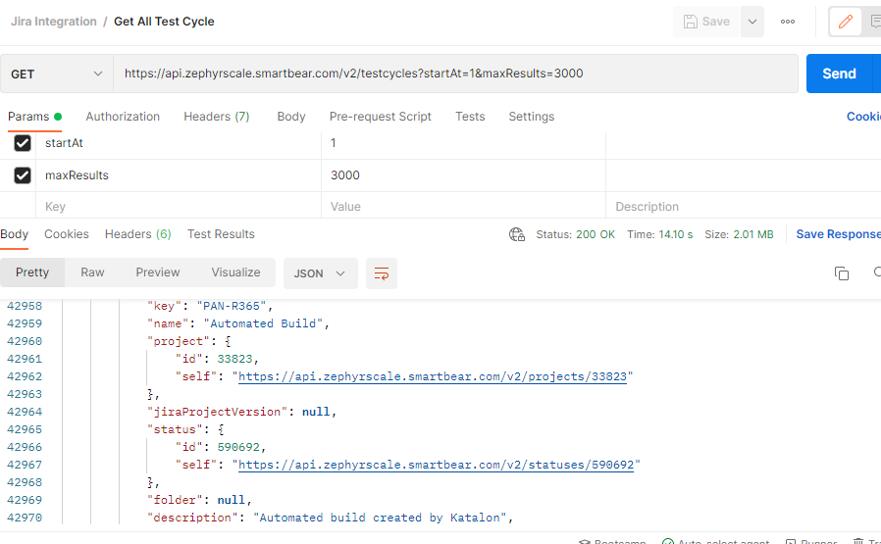

- Get TestCycle: This API will be useful to get the test cycle details which exists in Zephyr Scale.

Endpoint URL: https://api.zephyrscale.smartbear.com/v2/testcycles/{testCycleIdOrKey}
HTTP method: Get
Output: Respective project details in JSON format.

For more Information please refer below link,
https://support.smartbear.com/zephyr-scale-cloud/api-docs/#operation/getTestCycle
Example:
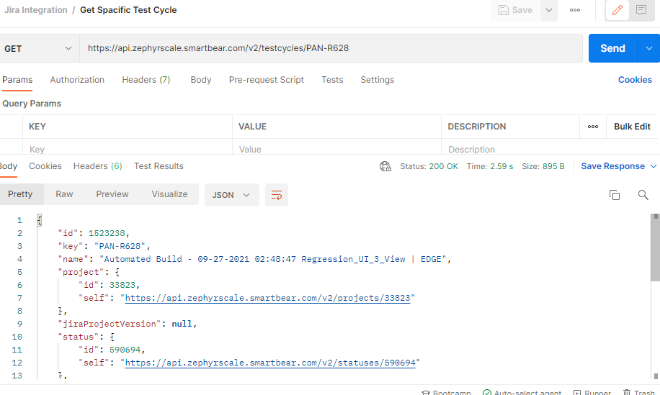

6.Uploading xml into Zyperscale API.
API: https://api.zephyrscale.smartbear.com/v2/automations/executions/junit?projectKey=PAN&autoCreateTestCases=true
HTTP method: post method.
Output: Respective project details in JSON format.

For more Information please refer below link,
https://support.smartbear.com/zephyr-scale-cloud/docs/test-automation/pytest-integration.html
Example:

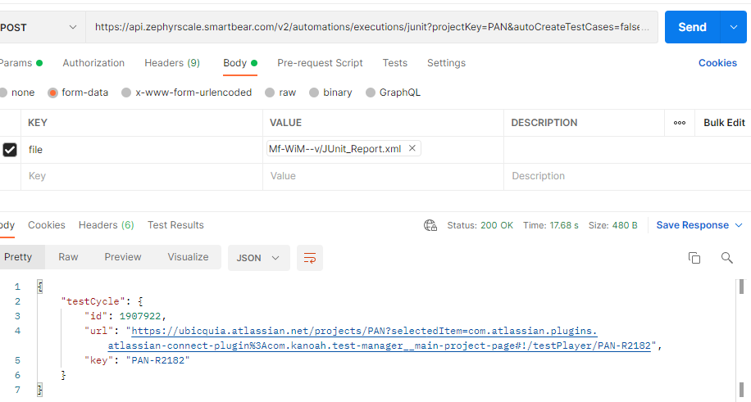
Output:

Test cycle data is -->{
"testCycle": {
"id": 1907922,
"url": "https://ubicquia.atlassian.net/projects/PAN?selectedItem=com.atlassian.plugins.atlassian-connect-plugin%3Acom.kanoah.test-manager__main-project-page#!/testPlayer/PAN-R2182",
"key": "PAN-R2182"
}
}

When create a new test cycle it will not assign to any folder as shown below in the screenshot.

    - Update test cycle:
API: https://api.zephyrscale.smartbear.com/v2/testcycles/{testCycleIdOrKey}
HTTP method: put method.
Output: Respective project details in JSON format.

For more Information please refer below link,
https://support.smartbear.com/zephyr-scale-cloud/api-docs/#operation/updateTestCycle
Example: Below is the code to update the above created test cycle to
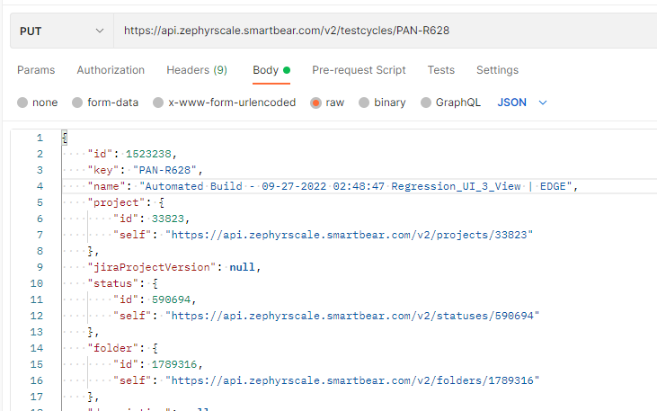

After update the test cycle you can find the PAN-R628 has updated to the Automated Build-January folder.

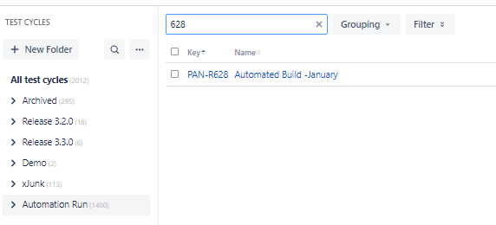

4. Finding the required project Details as per the requirement.

Project key can be find in the home page as shown below. Using this key we can find the project ID.

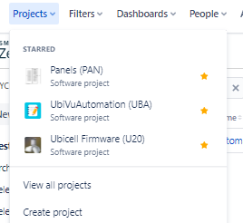

API: https://api.zephyrscale.smartbear.com/v2/projects/{projectIdOrKey}

Example: For project key PAN, the respective project ID is 33823. This ID is useful to upload the results in Zephyr Scale.
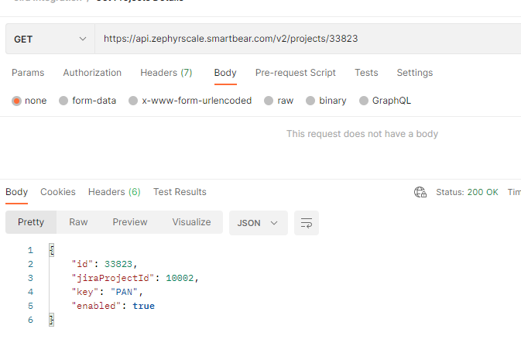

Creating Folder Structure as per the requirement.

On the begining process should create the the folder structure as below on each month depends on calendar date.

- Aug --> 01-08-2021 , 02-08-2021 , 03-08-2021 .. etc.
- Sep --> 01-09-2021 , 02-09-2021 , 03-09-2021 .. etc.

Basically process should create root folder as Jan and sub folder as 01-01-2022, 02-01-2022 etc..

Creating folder, subfolders:

- API : https://api.zephyrscale.smartbear.com/v2/folders
- Input: API End point URL, access token vale, create folder payload.
- Output: Respective folder ID details.
- Python code: api.post_request(url=API, header_value=access_token_value,payload=create_folder)

Below is the create_folder payload.

create_folder = {"parentId": "parentId_Dynamicvalue",
"name": "foldername_Dynamicvalue",
"projectKey": "PAN",
"folderType": "TEST_CYCLE"
}

month folder data :

The exact output is as below {"id": 1454614, "parentId": 1403782, "name": "January", "index": 1, "folderType": "TEST_CYCLE", "project": {"id": 33823, "self": "33823"}}

Note: When creating month folder i.e June, July ,Aug parentID should be the folder ID of Daily Automation folder as shown in the below screen. To get the folderID of root folder please use below API. It is a get request.

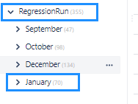
API: https://api.zephyrscale.smartbear.com/v2/folders
Please look for Daily automation folder name where you can find the ID of the folder, use the same folder ID while creating the month folder.

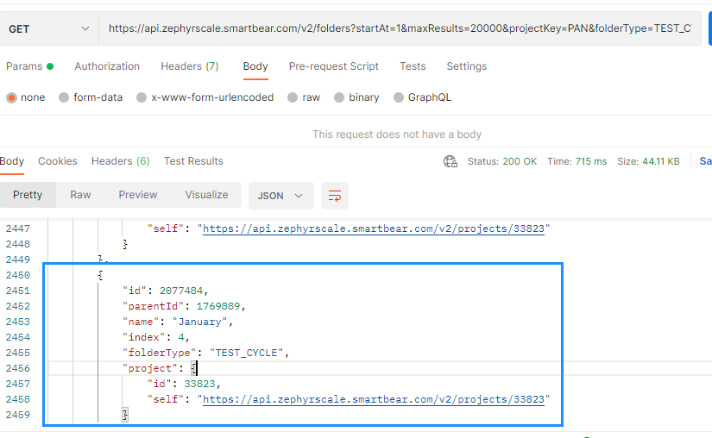

Date folder data :

While creating the date folder the parent ID should be Januart month folder ID.
You can get the folder Ids using above API.

{
"parentId":2077484 ,
"name": "1-1-2022",
"projectKey": "PAN",
"folderType": "TEST_CYCLE"
}

Below is the logic to create month, date folders.

- When there is a change in the month, process has to create one new root folder and the given date. An example it is jan month and the start of the date folder name.
i.e Jan -- > 01-01-2022.
- With in the jan month , on the given day 01-01-2022 , if the process is running second time it should not create new date folder , it should make use of existing date folder .. It has to avoid creating duplicate folder names.
- With in the jan month , if the dates are not matching it has to create the new date folder i.e 02-01-2022.

When the folder, sub folder's structure is ready , Now it is time to upload the XML file in Zira to the respective folderID.

Generate XML Report using Pytest(If You have a Katalon Studio then Junit File is creating by default)

Generate the XML report using below command.
py.test test_suiteCityIQ.py --html="./Reports/report.html" –junitxml="./Reports/cityiq.xml"

Upload the XML results:

header = {"Authorization": "Bearer AccessToken"}
Use below API to upload the data in Zephyr Scale website.
- API: https://api.zephyrscale.smartbear.com/v2/automations/executions/junit?projectKey=PAN&autoCreateTestCases=true
- Input: XML file
- Output: test cycle ID, test cycle URL.
- URL: requests.post(ZSConfig.testexecution_url, headers=header, files=XM_file_name)
- Katalon code: CustomKeywords.'ubicquia.sync.zephyr.KatalonZephyrIntegration.postJunitXMLReport'('Post - Junit Xml Format',zipName)

- Custome Method
@Keyword
def ResponseObject postJunitXMLReport(String tc,def filePath){
RequestObject request = findTestObject('ZephyrAPI/'+tc)
TestObjectProperty authorization = new TestObjectProperty('Authorization', ConditionType.EQUALS,GlobalVariable.Jira_AccessToken)
TestObjectProperty contentType = new TestObjectProperty("Content-Type", ConditionType.EQUALS, "multipart/form-data")
ArrayList header = Arrays.asList(authorization,contentType)
request.setHttpHeaderProperties(header)
def formdataparam = new FormDataBodyParameter('file', filePath, 'File')
request.setBodyContent(new HttpFormDataBodyContent([formdataparam]))
def response = WS.sendRequest(request)
return response
}

It generates the new testcycle ID & new testcycle URL. This test cycle must be attached with the sub folder id i.e 01-01-2022.

In order to update the test cycle ID, please use below API

- API: "https://api.zephyrscale.smartbear.com/v2/testcycles/"
- Katalon Code:
@Keyword
def ResponseObject putUpdateTestCycle(String tc,String testCycleIdOrKey,int testCycleId,String testCycleKey,String name,int projectId,int folderID){

RequestObject request = findTestObject('ZephyrAPI/'+tc,[('testCycleIdOrKey'):testCycleIdOrKey])
TestObjectProperty authorization = new TestObjectProperty('Authorization', ConditionType.EQUALS,GlobalVariable.Jira_AccessToken)
TestObjectProperty contentType = new TestObjectProperty("Content-Type", ConditionType.EQUALS, "application/json")
ArrayList header = Arrays.asList(authorization,contentType)
request.setHttpHeaderProperties(header)
request.setBodyContent(new HttpTextBodyContent(putUpdateTestCycle(testCycleId,testCycleKey,name,projectId,folderID)))
def response = WS.sendRequest(request)
return response
}
output: It returns the status code is 200. It means it is successfully updated.

Below is the payload of update_test_cycle.

update_testcycle = { "id": "testcycle_data[testCycle][id]",
"key": "testcycle_data[testCycle][key]",
"name": "Automated Build",
"project": {
"id": Project_ID,
"self": project_path
},
"status": {
"id": project_statusID,
"self": project_statusPath,
},
"folder": {
"id": "datefolder_id_dynamicvalue", # The folder ID of date . i.e 01-jan-2022
"self": "https://api.zephyrscale.smartbear.com/v2/folders/"
}
}

The other values are:

- Project_ID = 33823
- project_path = "https://api.zephyrscale.smartbear.com/v2/projects/33823"
- project_statusID = 593513
- project_statusPath = "https://api.zephyrscale.smartbear.com/v2/statuses/593513"

